**NAS ASSIGNMENT 3**

1. For the network given below.

a. Find the mathematical expression for the current passing through the resistance when the switch closes at t=0s. In the figure, the source v(t) = 0.1e-5t.

b. Plot the waveform of i2(t) for a period of time extending from t=0 to t=2s

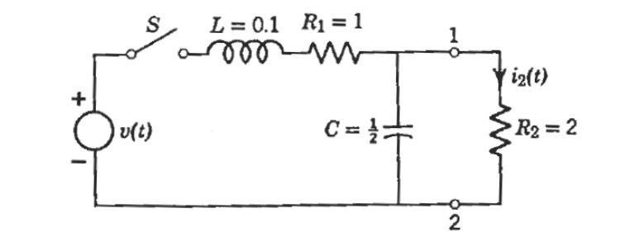

Ans:

Manual Solution:

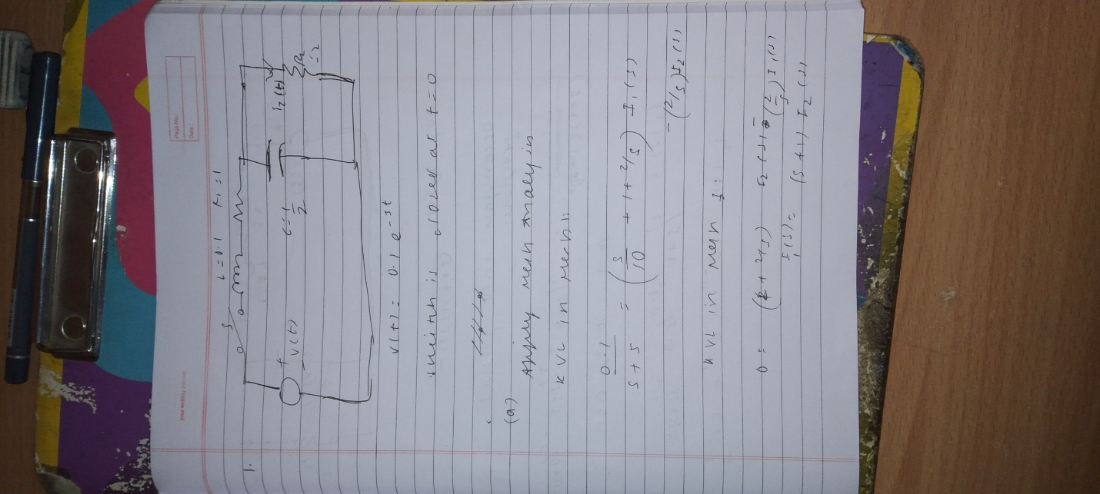

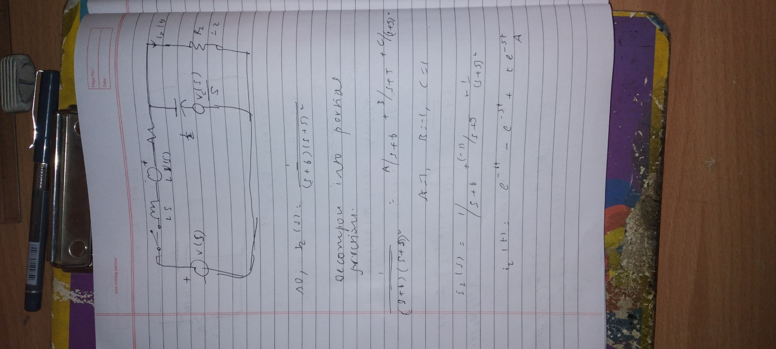

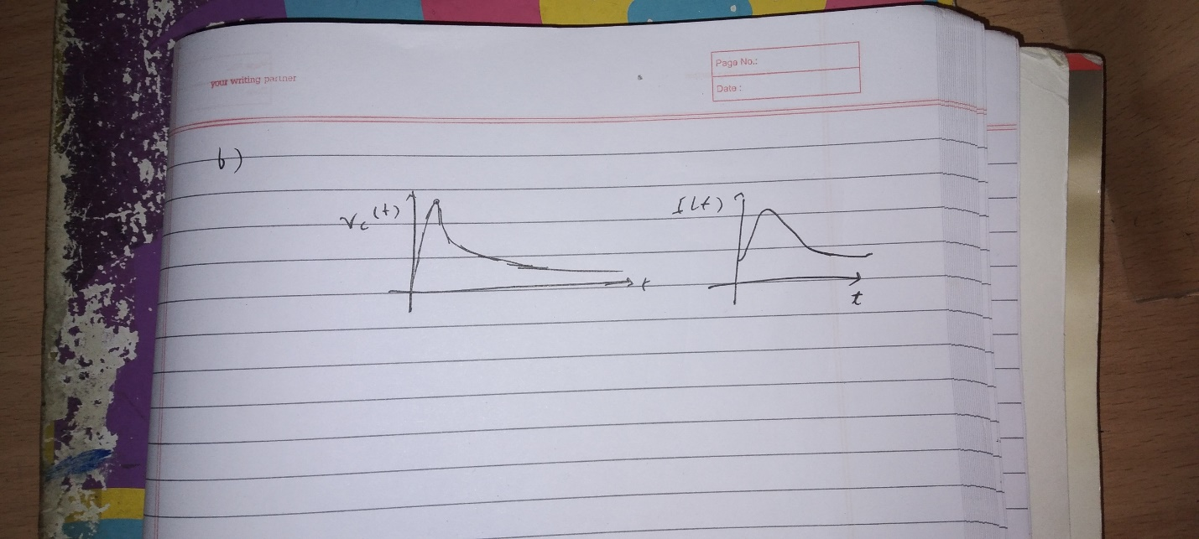

QUCS Solution:

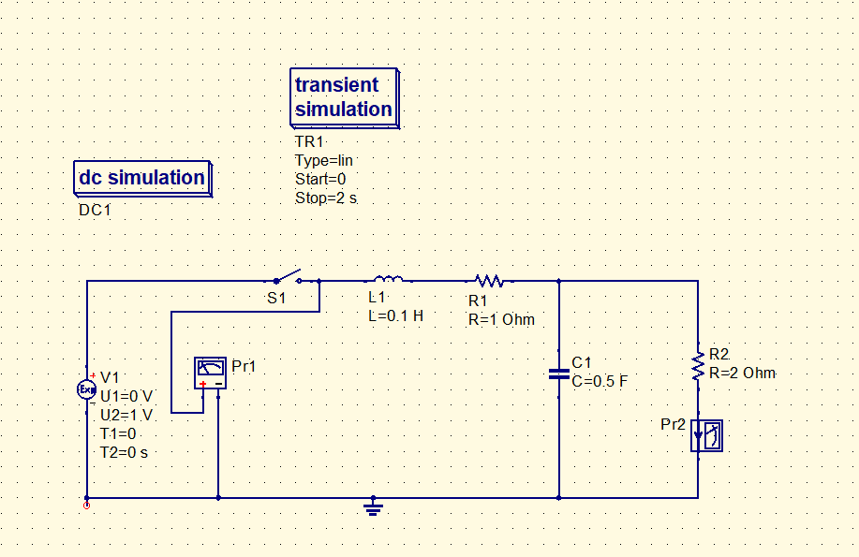

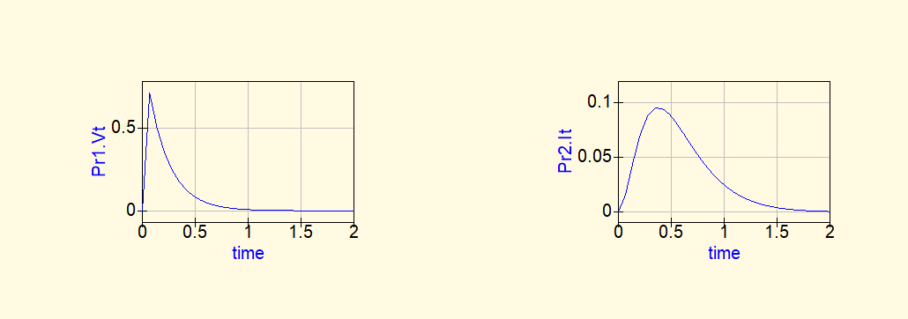

2. For the network given below:

a. Find the mathematical expression for voltage across the capacitor after switch is thrown into position 1.

b. Repeat part (a) for ic(t)

c. Find the mathematical expression for the voltages vc(t) and ic(t) if the switch is thrown into position 2 at a time equal to five-time constants of the charging circuit.

d. Plot the waveforms for Vc(t) and Ic(t) from t=0s to t=30µs

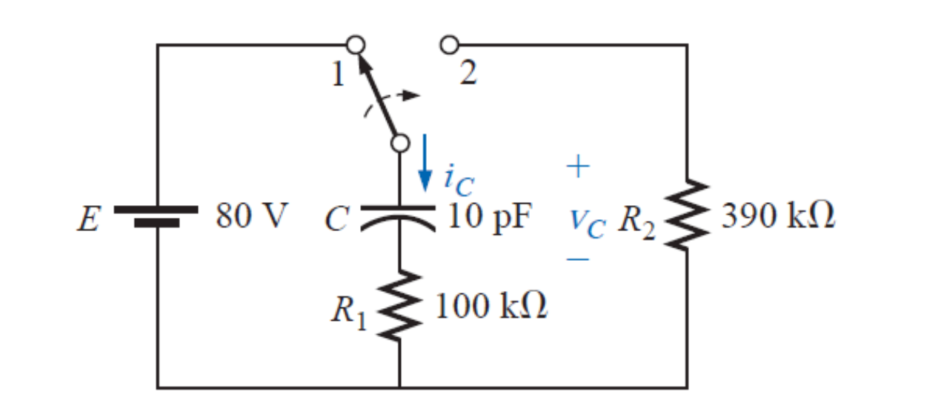

Ans:

Manual Solution:

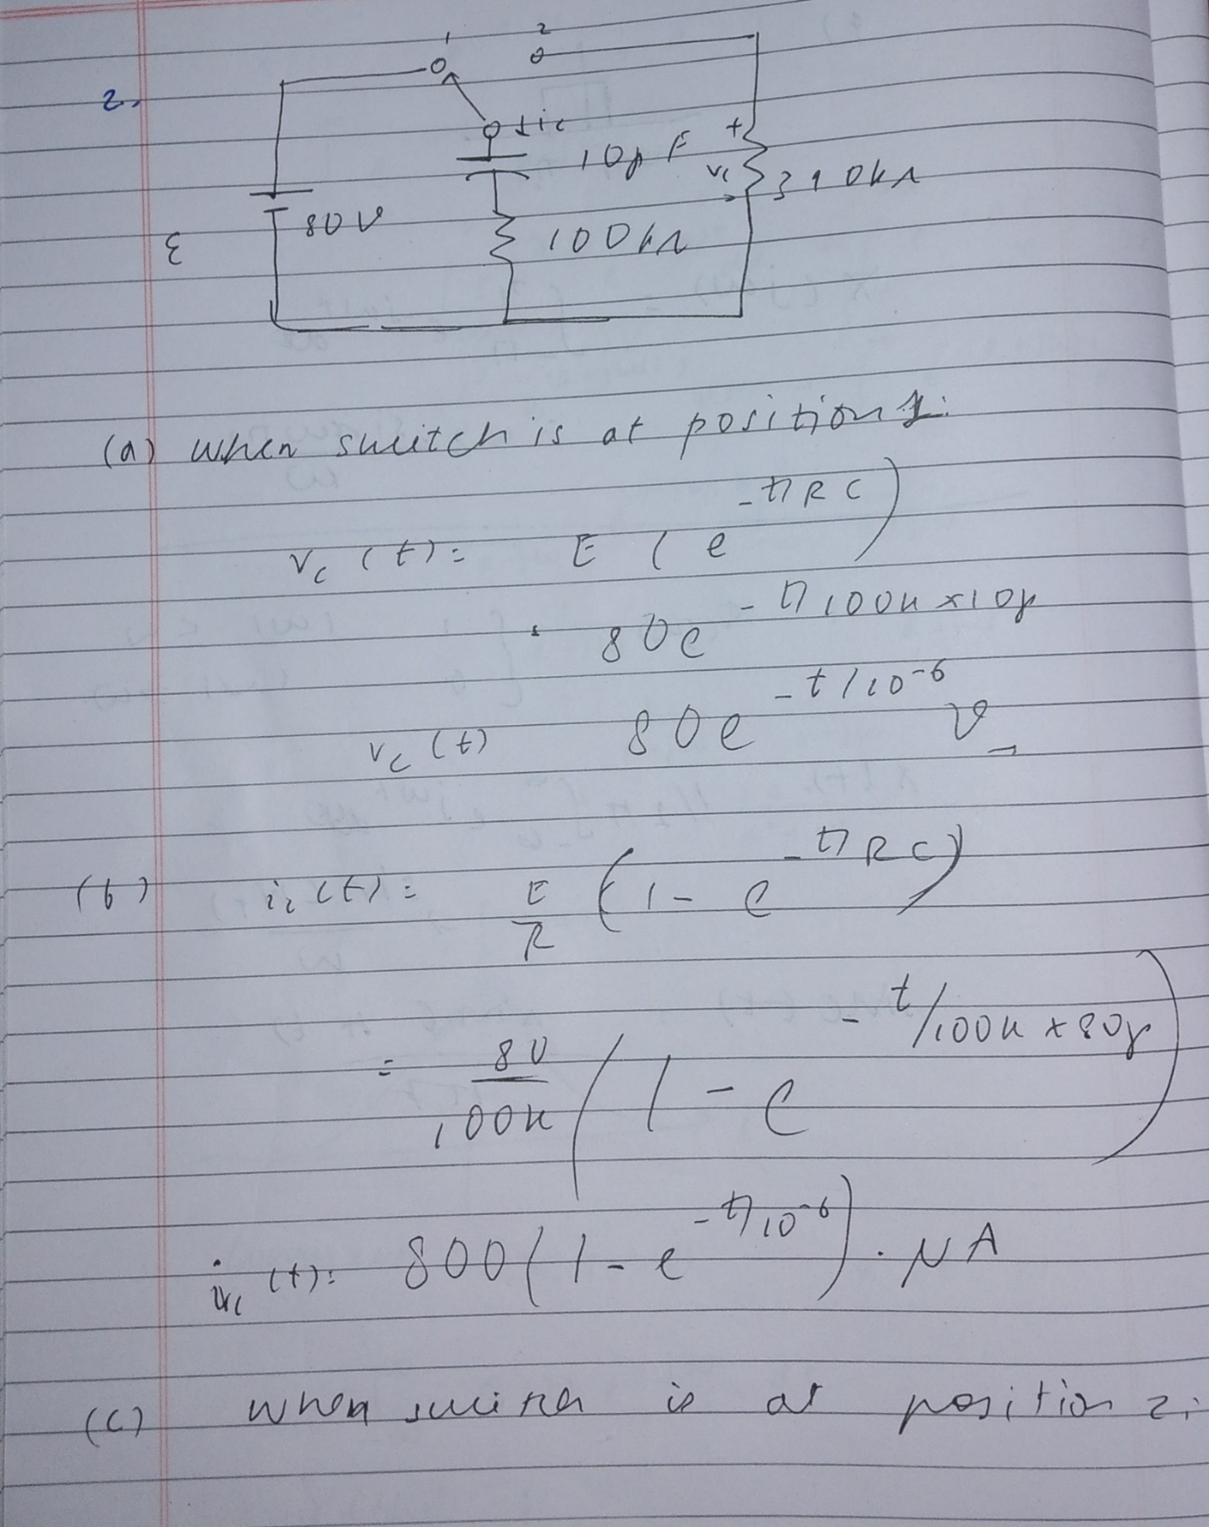

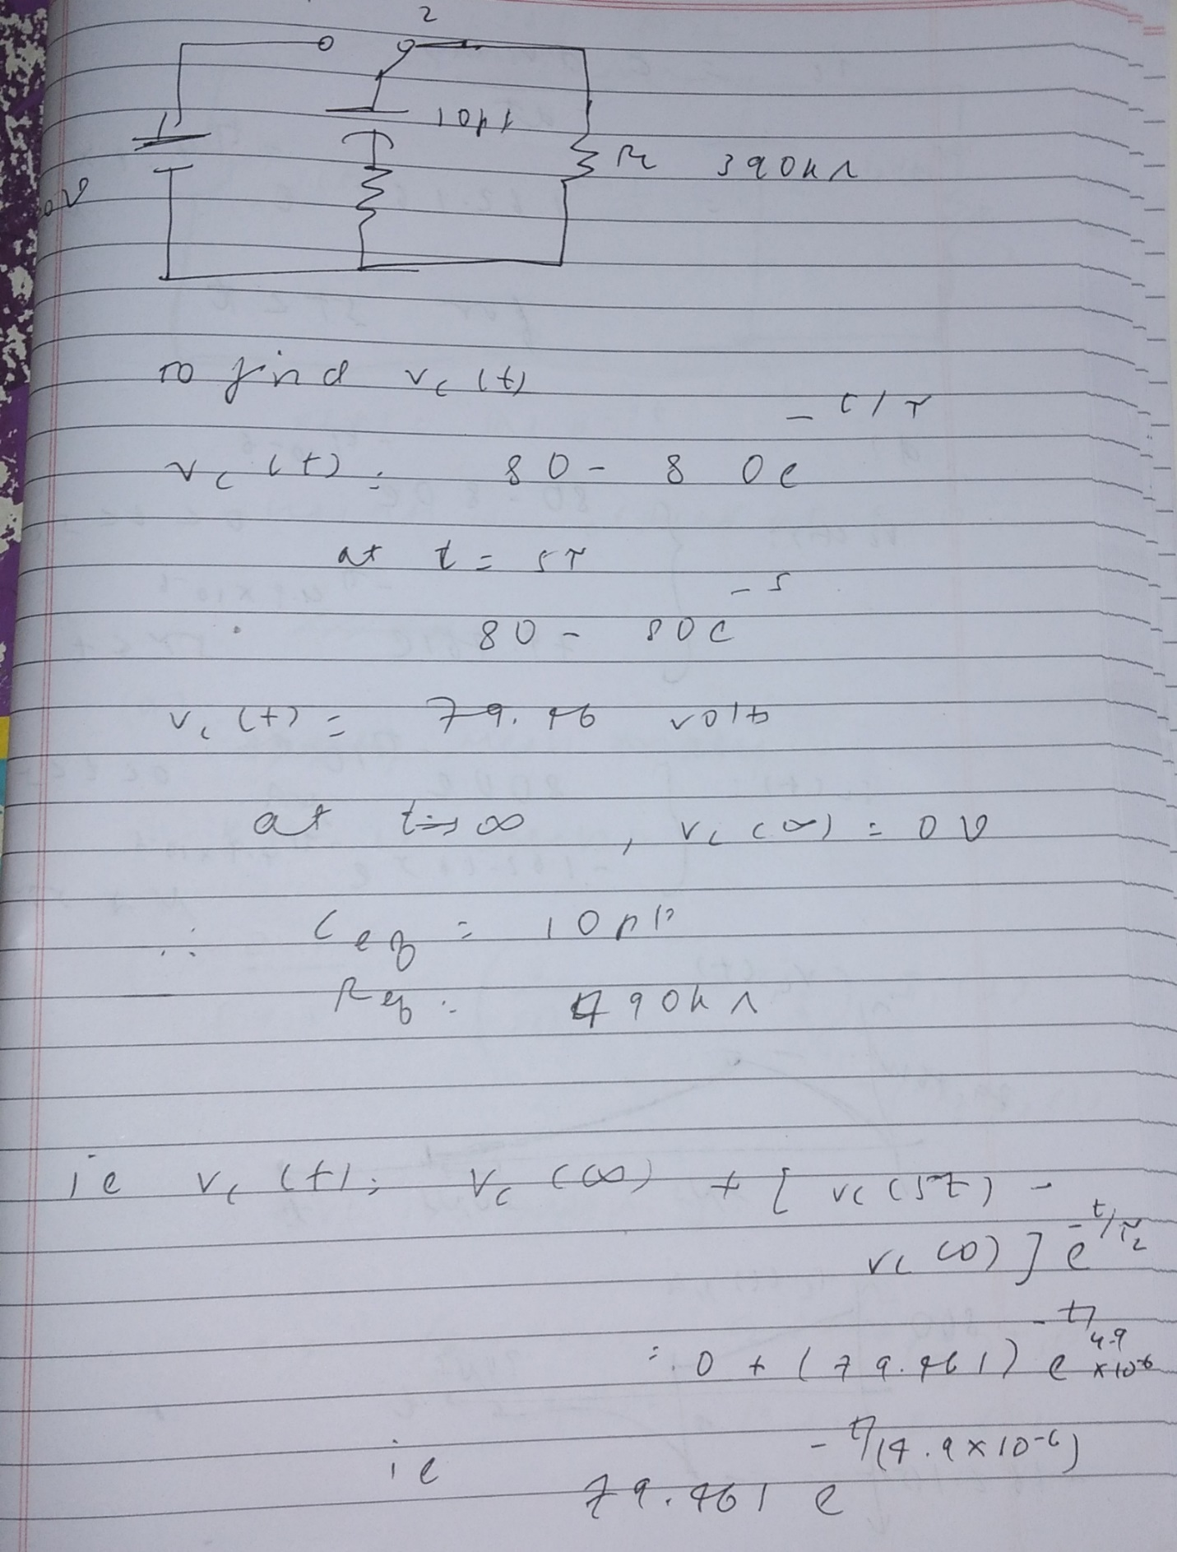

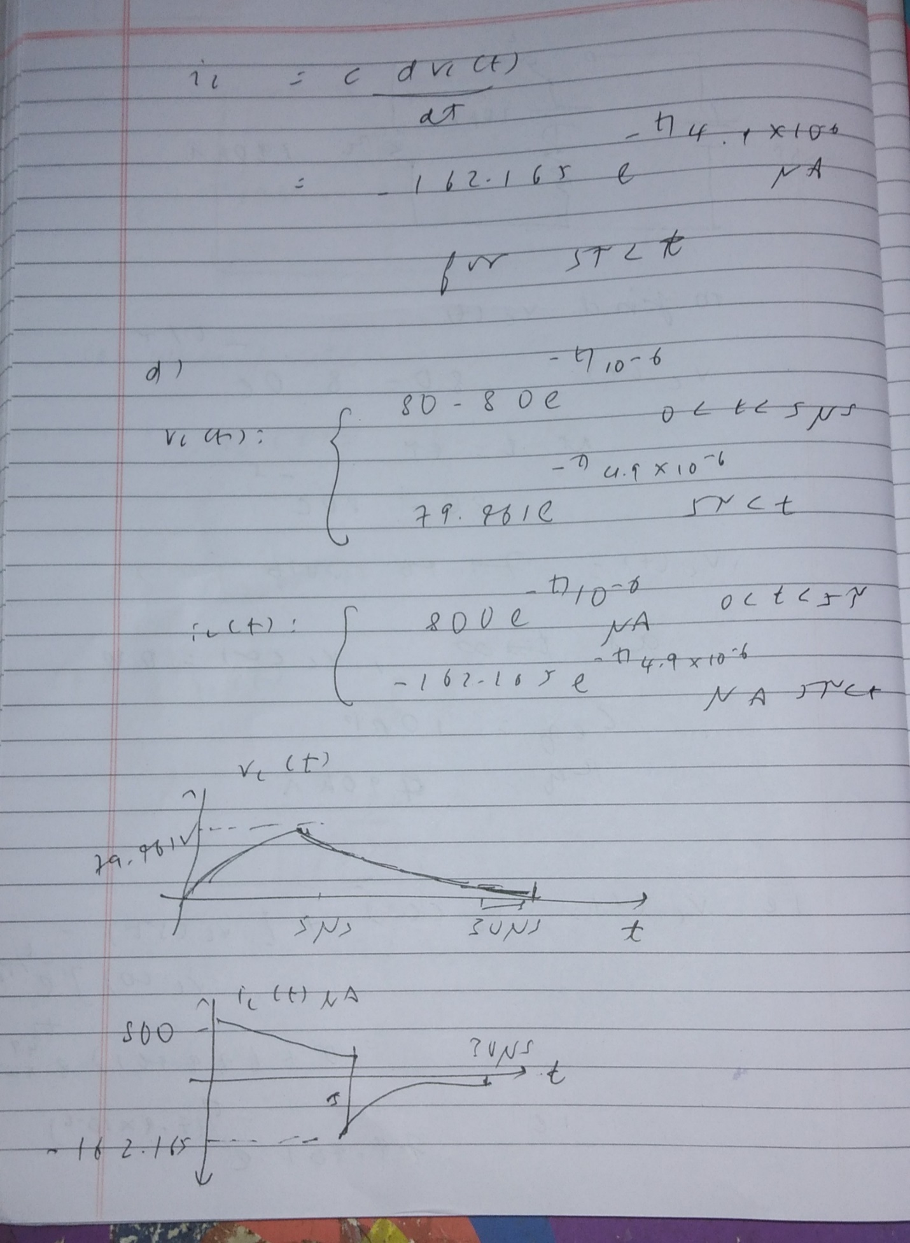

QUCS Solution:

